MACHINE LEARNING LAB

Project Report



**CLINICAL INSIGHT PREDICTION SYSTEM**

Submitted by:

|  |  |
| --- | --- |
| Muhammad Saif | 22F-3165 |
| Mariam Fatima | 22F-3168 |
| Muskan Ghani | 22F-3841 |

Submitted to:

Mr. Asif Ameer

12/08/2024

Department of Artificial Intelligence and Data Science

National University of Computer and Emerging Sciences, CFD

Contents

Introduction 3

Problem Analysis 3

Background 3

Challenges 3

Feasibility Analysis 3

Data Availability 3

Model Performance 4

Computational Resources 4

Cost 4

Technical Expertise 4

Possible Solution 4

Artificial Neural Network (ANN) 4

Support Vector Machine (SVM) 4

Random Forest 4

Logistic Regression 4

Proposed Design 4

Data Collection and Preprocessing 5

Feature Selection 5

Model Selection and Training 5

Prediction 5

Evaluation 5

Flow Chart Diagram 6

Design Description 6

Data Input and Preprocessing 6

Model Training and Validation 7

Prediction and Result Interpretation 7

Visualization and Reporting 7

Implementation Details 7

Libraries Used 7

Model Training 7

Evaluation Metrics 7

Data Preprocessing Steps 7

Confusion Matrix Visualization 7

Experiment Results 8

Artificial Neural Network (ANN) 8

Support Vector Machine (SVM) 8

Random Forest 8

Logistic Regression 8

Visualizations 8

Heart Disease 9

Confusion Matrix Comparison for Heart Disease Models 9

Skin Cancer 9

Confusion Matrix Comparison for Skin Cancer 9

Kidney Disease 9

Confusion Matrix Comparison for Kidney Disease 9

Asthma 9

Confusion Matrix Comparison for Asthma 9

Performance Analysis 9

Accuracy 9

Precision, Recall, and F1-Score 10

Confusion Matrices: 10

Overall Performance: 10

Future Scope 10

Model Improvements: 10

Additional Data Sources: 10

Real-Time Clinical Integration: 10

Model Interpretability: 10

Conclusion 10

References 11

Tools and Libraries: 11

Other resources 11

# Introduction

The rapid advancements in machine learning and data science have significantly impacted healthcare, especially in disease diagnosis. This project aims to leverage various machine learning algorithms, including **Artificial Neural Networks (ANN), Support Vector Machines (SVM), Random Forest, and Logistic Regression**, to predict the likelihood of diseases such as **Heart Disease, Kidney Disease, Asthma, And Skin Cancer.** The goal is to develop a **Clinical Insight Prediction System (CIPS)** that enables early disease detection, assisting healthcare professionals in making timely and informed decisions, thereby improving patient outcomes and reducing complications.

CIPS uses **Exploratory Data Analysis (EDA)** to extract meaningful insights from clinical data, applying machine learning techniques to build a robust, data-driven prediction system. By harnessing technology to optimize patient care, this project demonstrates the potential of integrating advanced analytics into healthcare for enhanced preventive care and accurate diagnosis.

# Problem Analysis

## Background

The increasing prevalence of diseases like Heart Disease, Kidney Disease, and Skin Cancer has placed immense pressure on healthcare systems. These diseases often exhibit:

**Subtle Early Symptoms**: Often ignored or undetected by traditional diagnostic methods.

**Complex Interdependencies**: Between patient demographics, lifestyle, and medical history.

## Challenges

1. **Delayed Diagnosis**: Leading to advanced disease stages and poor outcomes.
2. **Generic Risk Assessment**: Limited to standardized thresholds that fail to consider individual variations.
3. **Data Overload**: Manual processing of clinical data is time-intensive and prone to errors.

The Clinical Insight Prediction System addresses these challenges by applying machine learning to large datasets, identifying patterns that support earlier and more accurate predictions.

# Feasibility Analysis

This study investigates the feasibility of using machine learning algorithms to predict disease outcomes with available datasets. The feasibility is assessed based on several factors:

## Data Availability

Datasets for various diseases, including heart disease, kidney disease, asthma, and skin cancer, are available and have sufficient records for model training and validation.

## Model Performance

Preliminary experiments with different machine learning algorithms such as **ANN, SVM, Random Forest, and Logistic** **Regression** show promising results in terms of accuracy and prediction capabilities.

## Computational Resources

The training of machine learning models requires moderate computational power. Given the current hardware and software infrastructure, including cloud-based services, training the models for this project is feasible within the time constraints.

## Cost

The cost of implementing machine learning models is low since open-source libraries such as TensorFlow, and scikit-learn are freely available.

## Technical Expertise

The project leverages existing expertise in machine learning and healthcare datasets, which ensures the technical feasibility of successfully completing the project.

# Possible Solution

In this project, multiple machine learning algorithms have been explored to predict clinical outcomes for diseases like Heart Disease, Asthma, Skin Cancer, and Kidney Disease. The following solutions were considered:

## Artificial Neural Network (ANN)

A deep learning algorithm that has shown good performance in capturing complex patterns and relationships within the dataset. However, it requires a large amount of training data and is computationally expensive.

## Support Vector Machine (SVM)

A supervised learning algorithm known for its effectiveness in high-dimensional spaces. It performs well on classification problems but may struggle with large datasets and can be computationally intensive with increased data size.

## Random Forest

An ensemble learning method based on decision trees. It provides a robust model that is less prone to overfitting and performs well with both large and small datasets. It's efficient and easy to use, making it a suitable choice for this task.

## Logistic Regression

A simpler model that works well for binary classification problems. Although it may not capture non-linear relationships as effectively as more complex models, it is fast and easy to interpret.

# Proposed Design

The proposed design consists of a multi-step process where clinical data is processed, analyzed, and classified using machine learning models. The steps include:

## Data Collection and Preprocessing

* Clinical data (e.g., patient history, symptoms, test results) is collected and cleaned.
* Missing values, categorical data encoding, and normalization are handled during preprocessing.

## Feature Selection

* Key features are selected using statistical methods and domain knowledge to ensure the most relevant features are used for model training.

## Model Selection and Training

* Four models—ANN, SVM, Random Forest, and Logistic Regression—are trained on the data using cross-validation to avoid overfitting.

## Prediction

* Once trained, the models are used to predict the outcomes (e.g., disease presence or absence) based on new patient data.

## Evaluation

* Model performance is evaluated using metrics like accuracy, precision, recall, F1-score, and confusion matrices.

## Flow Chart Diagram

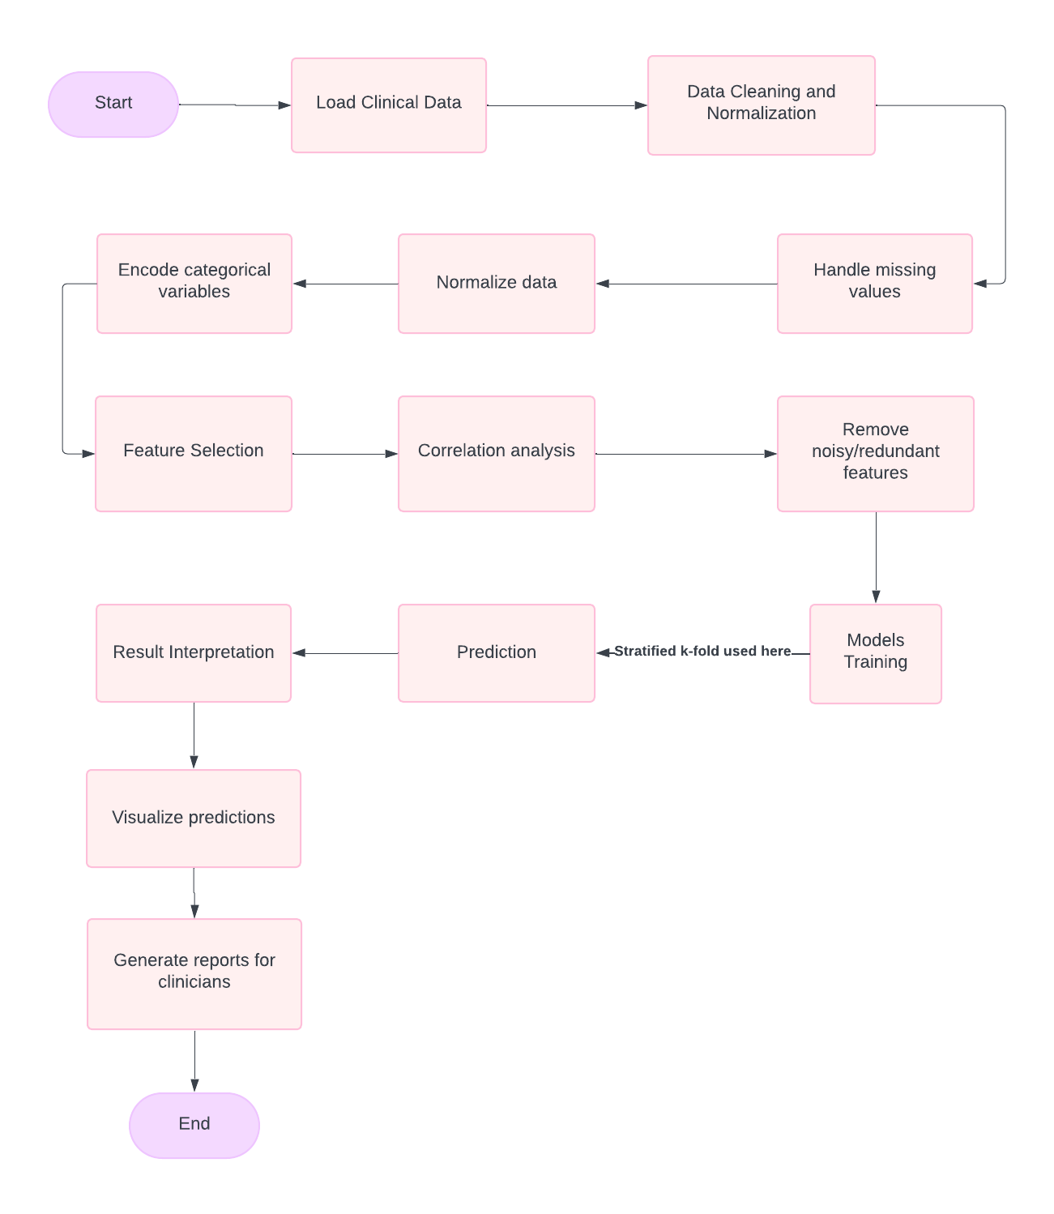

# Design Description

The design includes four primary components:

## Data Input and Preprocessing

Clinical data is collected in various formats. It is cleaned by **removing missing values, normalizing numerical data, and encoding categorical variables** (e.g., gender, medical history) to be machine-readable.

## Model Training and Validation

The models (**ANN, SVM, Random Forest, and Logistic Regression**) are trained using the training dataset. A hold-out validation dataset is used to fine-tune hyperparameters and assess model performance.

## Prediction and Result Interpretation

The trained models make predictions on new data, and the outcomes are evaluated using metrics such as **accuracy, precision, recall, and F1-score**. The results are interpreted in the context of clinical insights.

## Visualization and Reporting

**Confusion matrices and performance metrics** are visualized to compare the models' effectiveness in predicting clinical outcomes.

# Implementation Details

The project was implemented using Python and various machine learning libraries:

## Libraries Used

* **NumPy and Pandas:** For data manipulation and preprocessing.
* **Scikit-learn:** For building and evaluating machine learning models.
* **Keras/TensorFlow:** For training the Artificial Neural Network (ANN).
* **Matplotlib/Seaborn:** For visualizing results, including confusion matrices and model performance metrics.

## Model Training

* The dataset is split into training and test sets, with cross-validation used during model training to avoid overfitting.
* Hyperparameters for each model (ANN, SVM, Random Forest, and Logistic Regression) were optimized using grid search or random search methods.

## Evaluation Metrics

* Models were evaluated on several metrics, including accuracy, precision, recall, F1-score, and confusion matrices.

## Data Preprocessing Steps

* Data was cleaned to handle missing values, normalize numerical features, and encode categorical features using one-hot encoding.

## Confusion Matrix Visualization

* **Confusion matrices** were plotted for each model to evaluate true positives (TP), false positives (FP), false negatives (FN), and true negatives (TN).

# Experiment Results

## Artificial Neural Network (ANN)

|  |  |  |  |  |
| --- | --- | --- | --- | --- |
| Algorithm | Accuracy | Precision | Recall | F1-Score |
| Heart Disease | **77%** | **82%** | **73%** | **77%** |

## Support Vector Machine (SVM)

|  |  |  |  |  |  |
| --- | --- | --- | --- | --- | --- |
| Algorithm | Accuracy on Validation data | Accuracy on test data | Precision | Recall | F1-Score |
| Heart Disease | **75.5%** | **75.9%%** | **81%** | **72%** | **77%** |
| Kidney Disease | **92.3%%** | **92.6%** | **93%** | **100%** | **96%** |
| Asthma | **84.2%** | **84.3%** | **84%** | **100%** | **91%** |
| Skin Cancer | **85.8%** | **86.2%** | **86%** | **100%** | **93%** |

## Random Forest

|  |  |  |  |  |  |
| --- | --- | --- | --- | --- | --- |
| Algorithm | Accuracy on Validation data | Accuracy on test data | Precision | Recall | F1-Score |
| Heart Disease | **75.3%** | **76.0%** | **79%** | **77%** | **78%** |
| Asthma | **82.6%** | **82.4%** | **85%** | **97%** | **90%** |
| Skin Cancer | **85.8%** | **86.2%** | **86.0%** | **100%** | **93.0%** |

## Logistic Regression

|  |  |  |  |  |  |
| --- | --- | --- | --- | --- | --- |
| Algorithm | Accuracy on Validation data | Accuracy on test data | Precision | Recall | F1-Score |
| Kidney Disease | **92.3%** | **92.6%** | **93%** | **100%** | **96%** |

# Visualizations

Highlighting model accuracy for true vs. predicted outcomes.

## Heart Disease

### Confusion Matrix Comparison for Heart Disease Models

|  |  |  |  |  |
| --- | --- | --- | --- | --- |
| Model | True Positive (TP) | False Positive (FP) | False Negative (FN) | True Negative (TN) |
| ****Random Forest**** | 4917 | 1490 | 1342 | 4065 |
| ****Artificial Neural Network**** | 4699 | 1708 | 1051 | 4356 |
| ****Support Vector Machine**** | 4639 | 1768 | 1074 | 4333 |

## Skin Cancer

### Confusion Matrix Comparison for Skin Cancer

|  |  |  |  |  |
| --- | --- | --- | --- | --- |
| Model | True Positive (TP) | False Positive (FP) | False Negative (FN) | True Negative (TN) |
| ****Logistic Regression**** | 10188 | 0 | 1625 | 1 |
| ****Support Vector Machine**** | 10188 | 0 | 1626 | 0 |

## Kidney Disease

### Confusion Matrix Comparison for Kidney Disease

|  |  |  |  |  |
| --- | --- | --- | --- | --- |
| Model | True Positive (TP) | False Positive (FP) | False Negative (FN) | True Negative (TN) |
| ****Logistic Regression**** | 10941 | 1 | 868 | 4 |
| ****Support Vector Machine**** | 10942 | 0 | 872 | 0 |

## Asthma

### Confusion Matrix Comparison for Asthma

|  |  |  |  |  |
| --- | --- | --- | --- | --- |
| Model | True Positive (TP) | False Positive (FP) | False Negative (FN) | True Negative (TN) |
| ****Random Forest**** | 9642 | 319 | 1754 | 99 |
| ****Support Vector Machine**** | 9961 | 0 | 1853 | 0 |

# Performance Analysis

Based on the results obtained from the various models, the following analysis is made:

## Accuracy

* The Random Forest and Logistic Regression models performed well across all disease predictions, showing consistent accuracy in both validation and test datasets.
* The Support Vector Machine (SVM) performed excellently for Kidney Disease (with 100% recall) and showed solid results for Asthma and Skin Cancer.

## Precision, Recall, and F1-Score

* SVM consistently achieved high recall, particularly for diseases like Asthma and Kidney Disease, which is crucial for medical applications where false negatives (e.g., undiagnosed diseases) should be minimized.
* ANN showed moderate results, but it was less effective than SVM for Heart Disease prediction.

## Confusion Matrices:

* Confusion matrices provided insights into model performance, highlighting the trade-off between true positives and false negatives. For example, the SVM model for Asthma had fewer false positives compared to other models, making it more reliable in minimizing unnecessary treatments.

## Overall Performance:

* The models showed good generalizability with validation and test sets, indicating that they could be applied to real-world clinical data with reliable performance.

# Future Scope

The future scope for improving the Clinical Insight Prediction System includes:

## Model Improvements:

* Exploring deep learning techniques further, such as Convolutional Neural Networks (CNN) and Recurrent Neural Networks (RNN), for more complex datasets (e.g., time-series data for disease progression).
* Implementing advanced ensemble methods, such as XGBoost or LightGBM, to enhance predictive accuracy.

## Additional Data Sources:

* Integrating more diverse datasets, including genetic data, lifestyle factors, and patient histories, to improve model predictions.

## Real-Time Clinical Integration:

* Developing a web-based or mobile application to integrate the prediction system into real-time clinical decision support systems, enabling healthcare providers to use the models in practice.

## Model Interpretability:

* Focusing on making the models more interpretable, so that healthcare professionals can better understand and trust the predictions for model explainability.

# Conclusion

The Clinical Insight Prediction System successfully demonstrates the power of machine learning in healthcare. By accurately predicting outcomes for critical diseases, the system provides a scalable, efficient, and effective solution for enhancing patient care. Future iterations aim to refine prediction accuracy further and expand system capabilities to encompass additional medical conditions.

# References

## Tools and Libraries:

* TensorFlow
* Pandas
* NumPy
* scikit-learn
* matplotlib
* seaborn
* Lucid chart

## Other resources

* Geeks For Geeks
* Chrome Browser